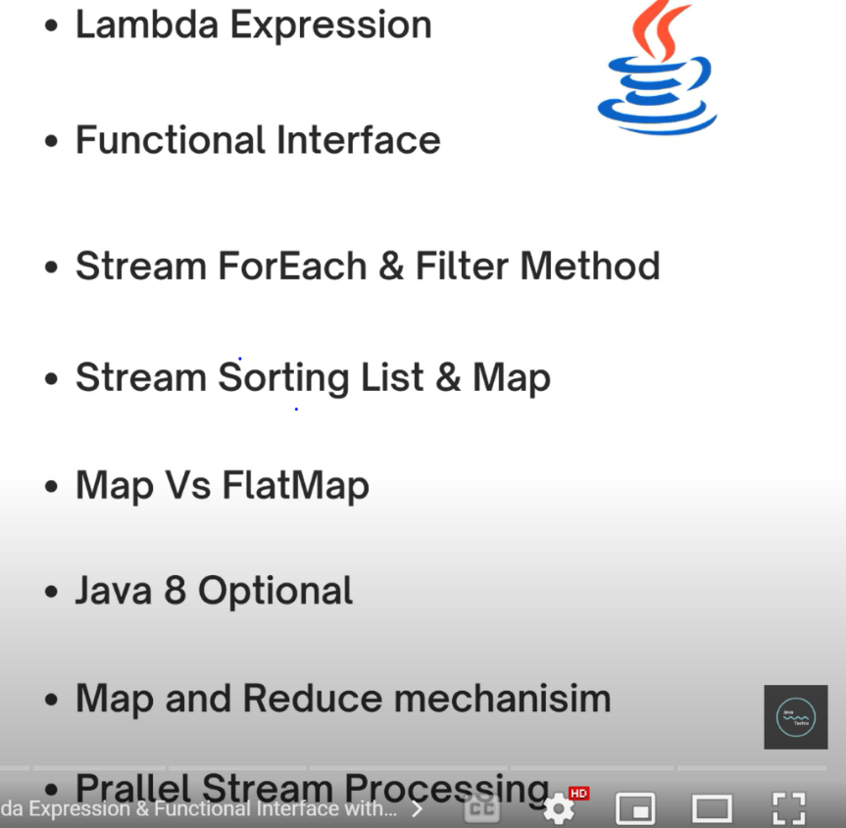

What is lambda expression and what is the need of lambda expression

Lambda expression is only applicable for functional interface

The method which is present in functional interface for that particular method only we can write functional interface

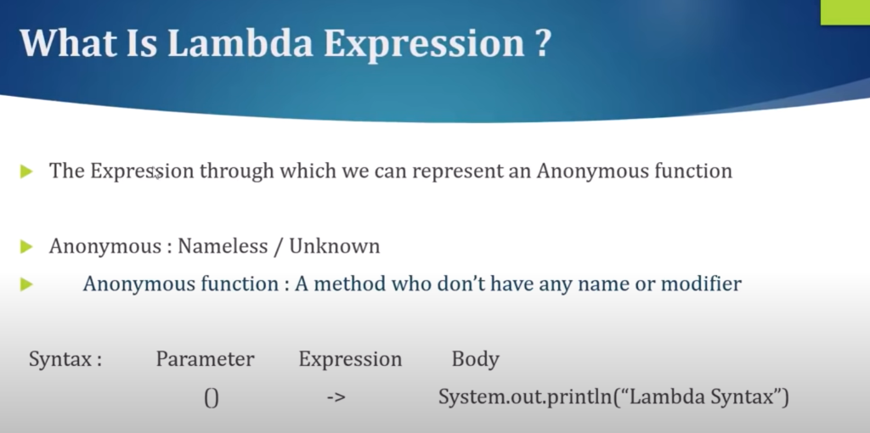

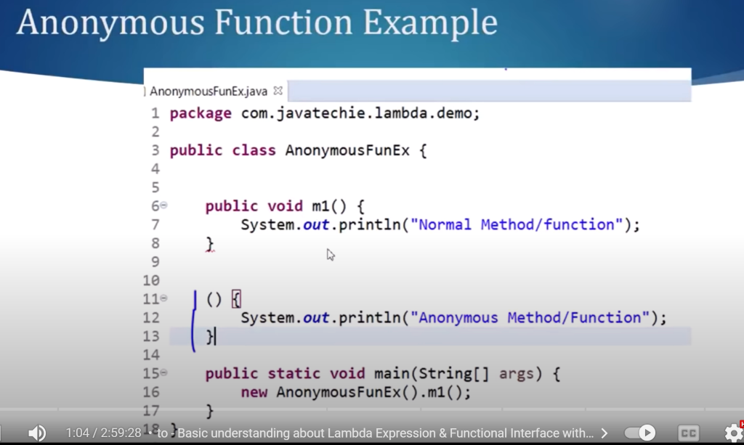

**Query :** for functional interface how to write lambda expression

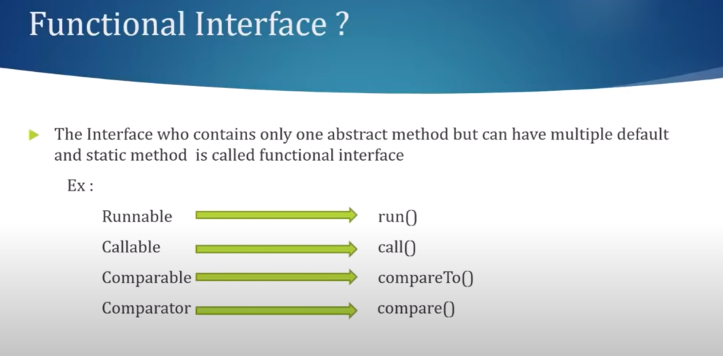

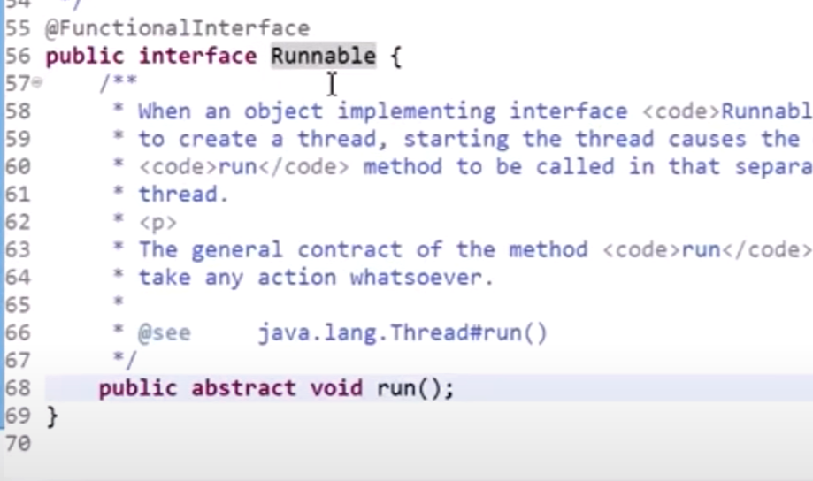

We can write our own functional interface also

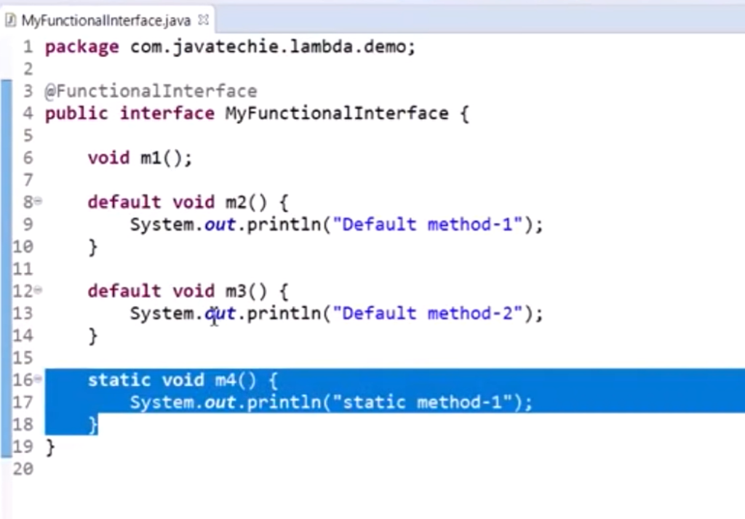

Syntax of lambda expression

Parameter expression body

()  -> {body}

**Note :**

Advantages of lambda expression  :  it will reduce the code length

Example 1

Example 2 : method with input

Example  3 : method with return type and multiple argument

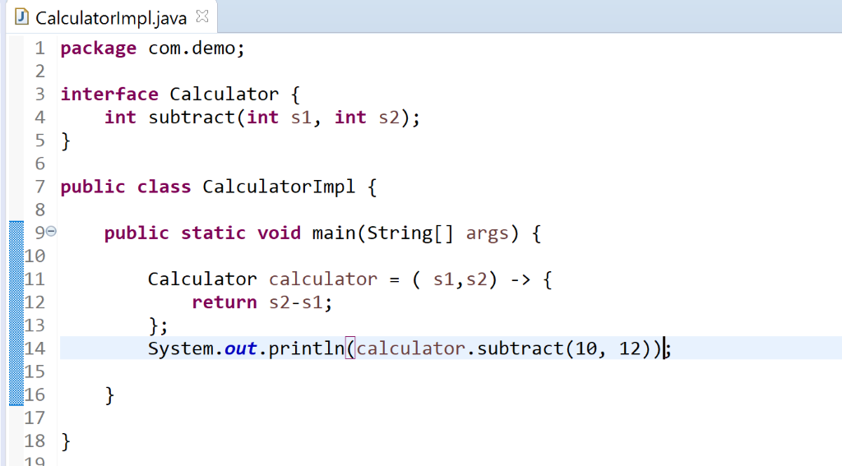

Since statement is one so we can write in one line and even we don’t need to write return statement

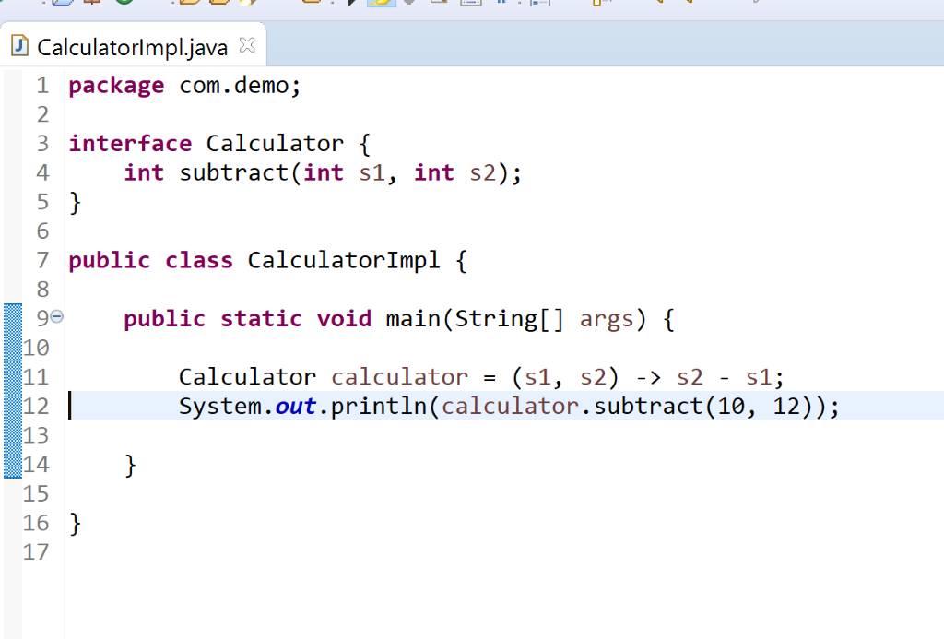

Want to do some business logic

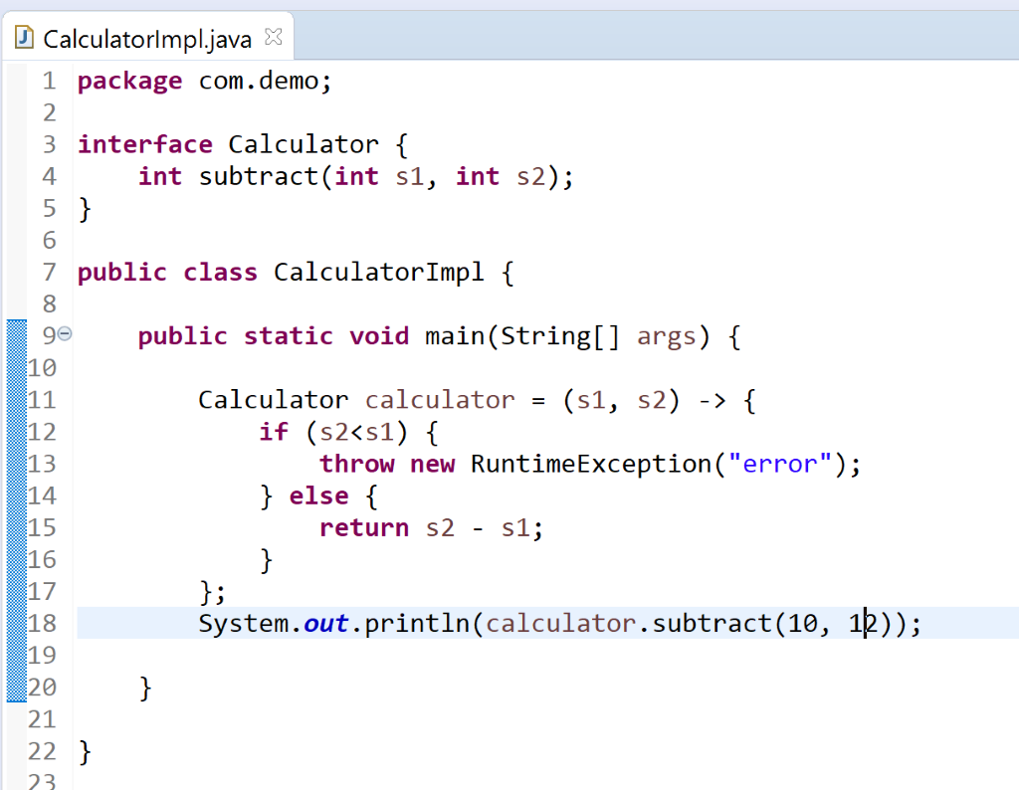

Example 4 : **write a method which will return list of book based on sorting order.**

**Traditional approach**

**Second approach** will write anonymous implementation of myComparator

**Predefined functional interface :**

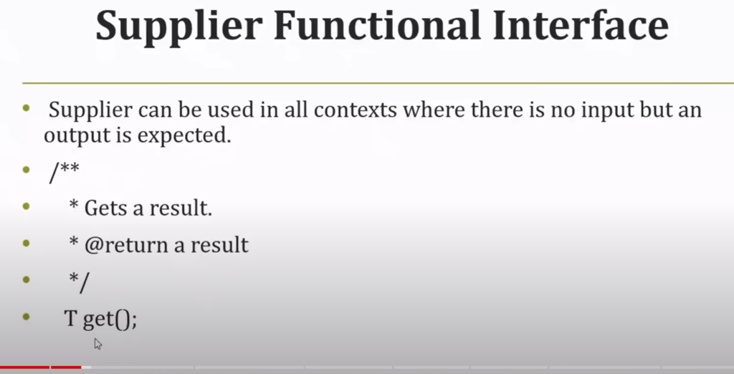

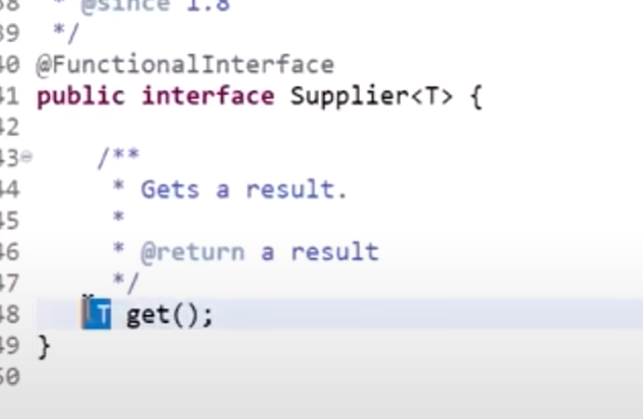

**1-  consumer interface** :-- have accept method which don’t have return type

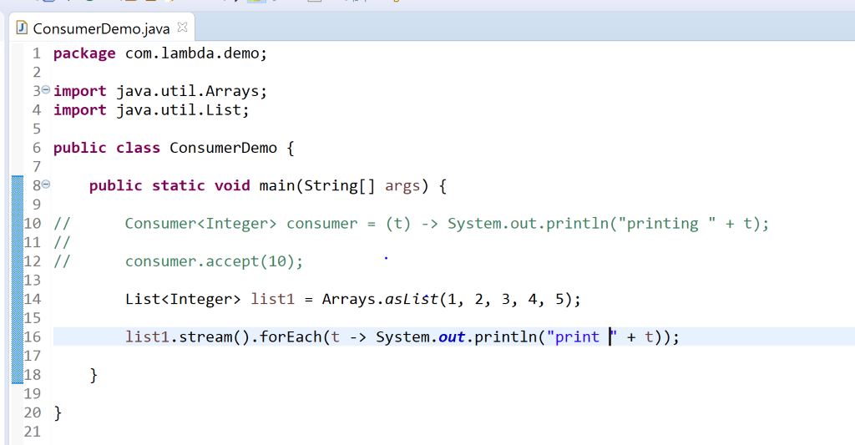

2- **predicate interface** :- have test method which will test

**We use predicate for conditional check**

Predicate we can use for filter method

**Supplier**

**Note :**

 We want to return some meaningful data then we can go for supplie**r**

What is stream api and few  of the method present in stream api

**ForEach :**internally using consumer interface

**Filter demo** :

1-the string which start with b want to print that

2- only for  0dd entry set print the result in map

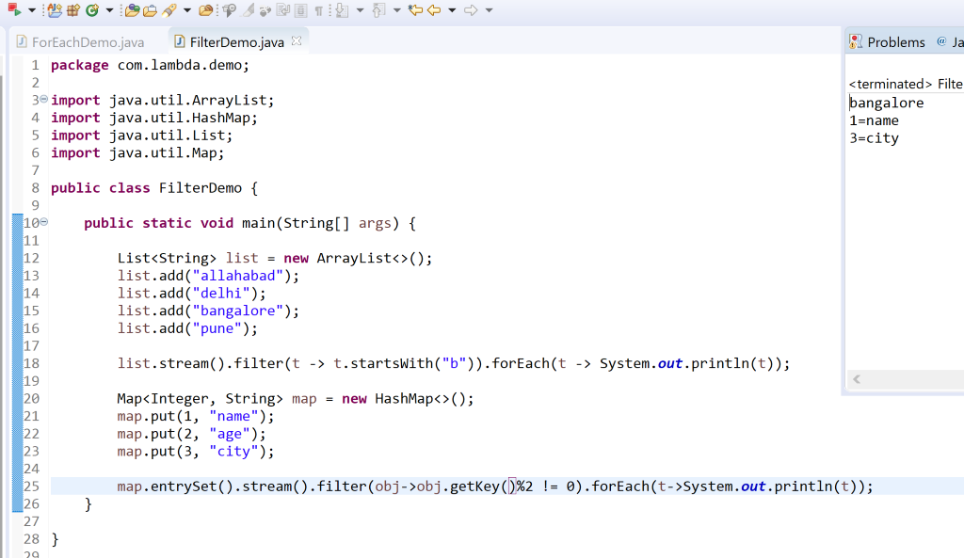

**Example**

**demo for stream api who is eligible to pay tax**

**Find emp salary more than 5 lakh**

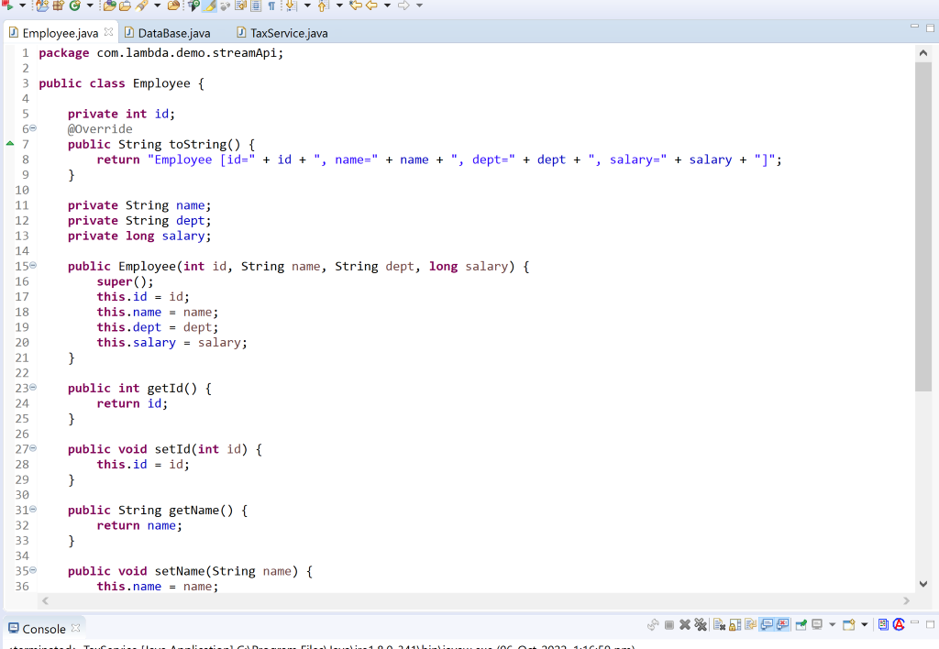

**Note :**

Sorted method is overloaded with comparator argument

**Sort primitive data type**

**Sort custom data type ( based on salary of employee)**

**How to sort using stream api**

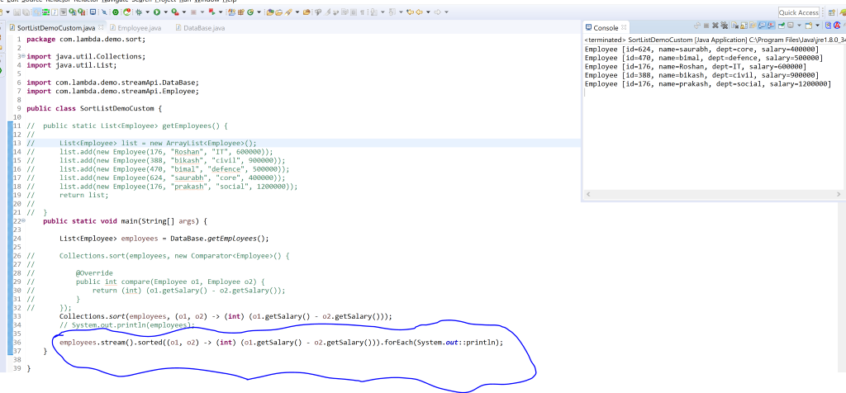

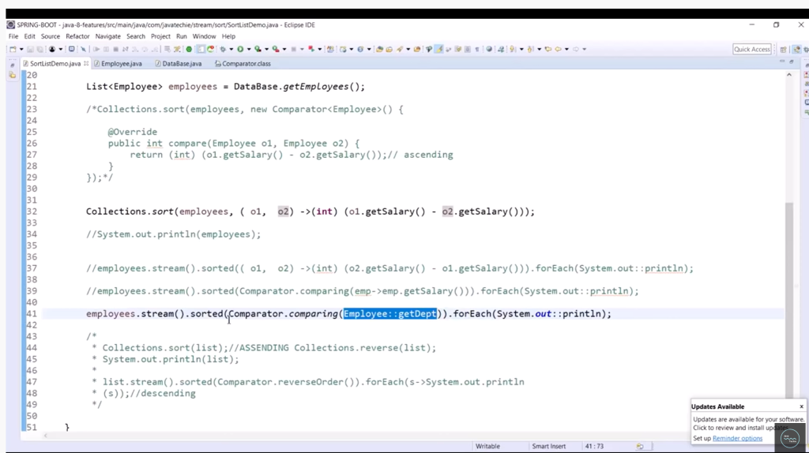



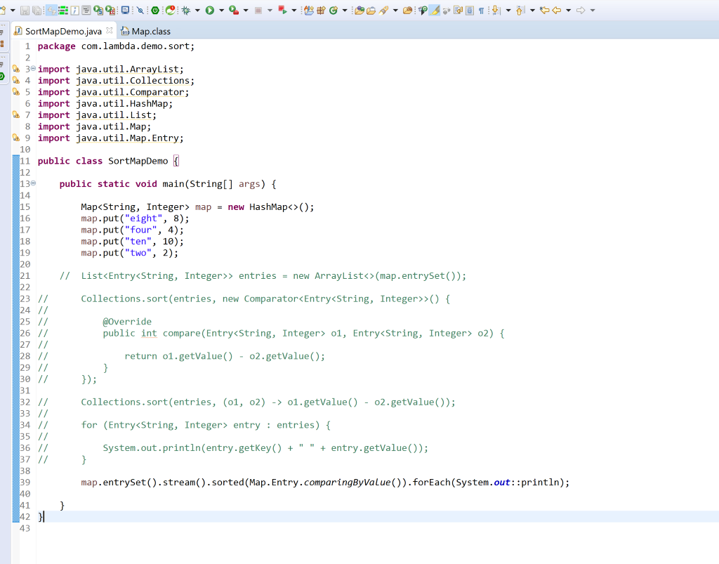

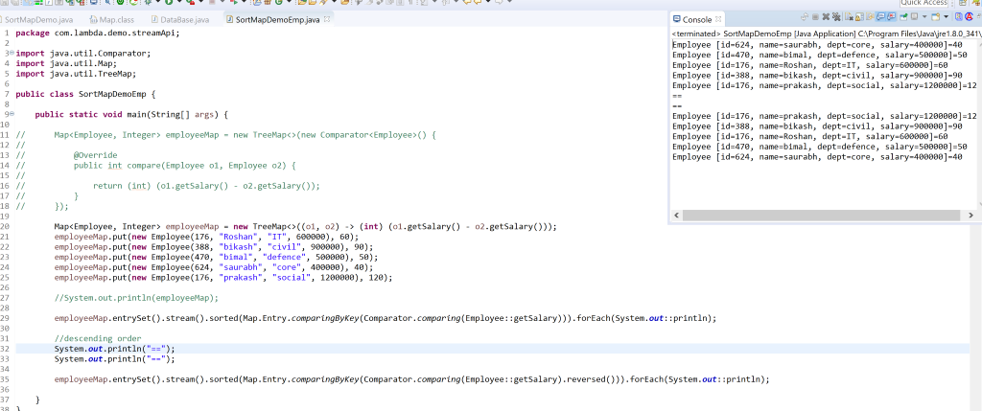

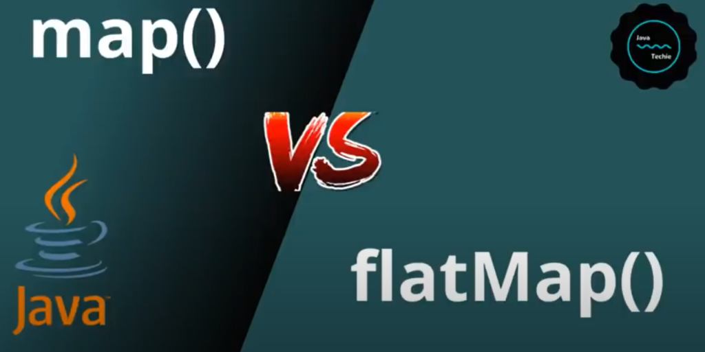

**Map :**

**It**takes input as stream and return output as another stream

**Requirement 1** : get list of email id from customer

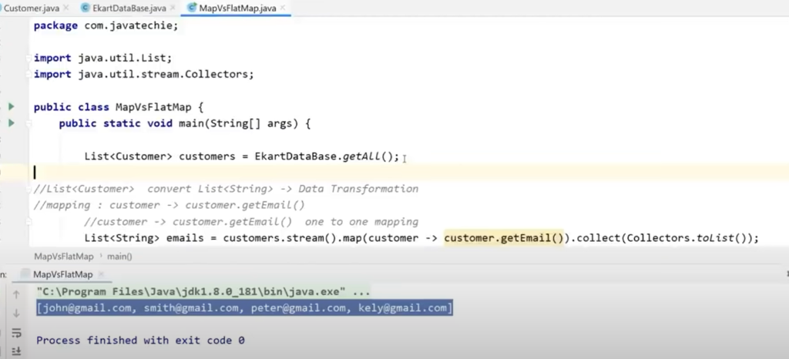

Note :

When we want to play with nested list we can go with flat map

**Data flattering means** : converting entire stream to single stream

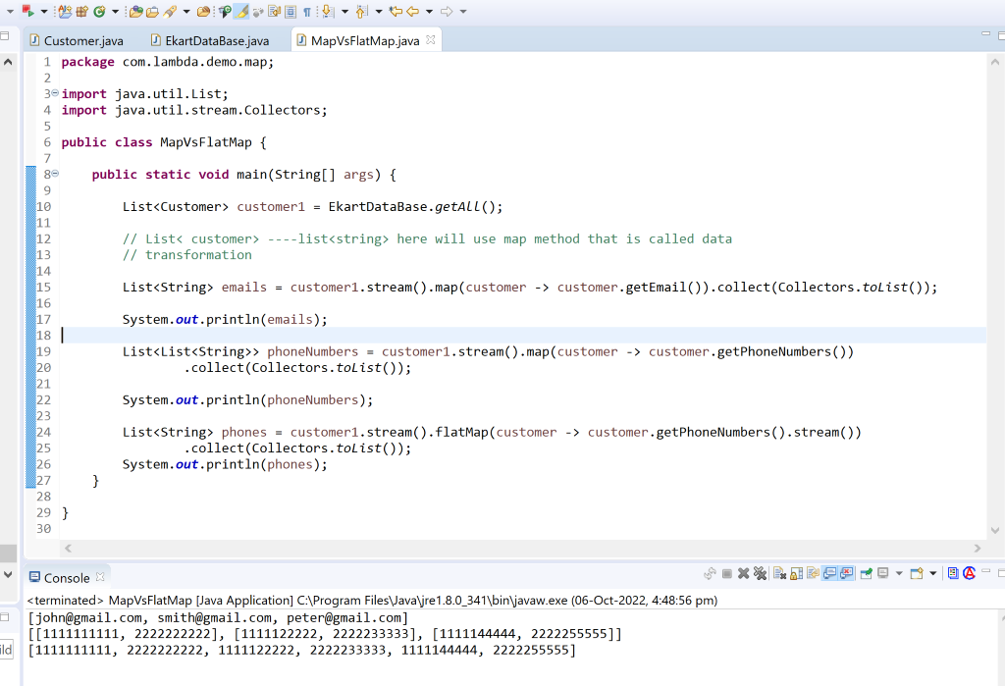

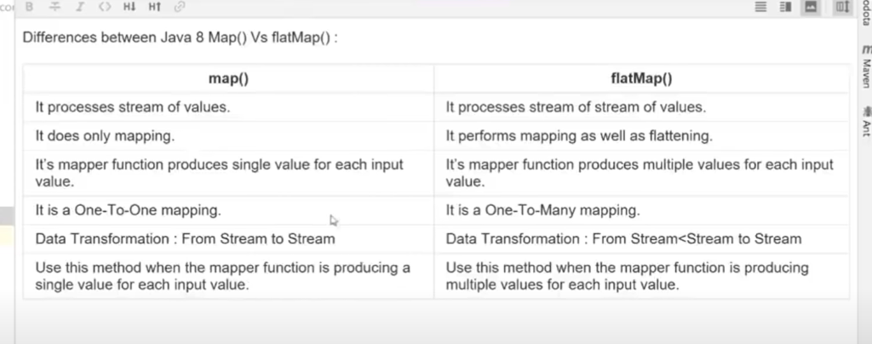

**map() function produces one output for one input value, whereas flatMap() function produces an arbitrary no of values as output (ie zero or more than zero) for each input value**.

**The map() method wraps the underlying sequence in a Stream instance, whereas the flatMap() method allows avoiding nested Stream<Stream<R>> structure**.

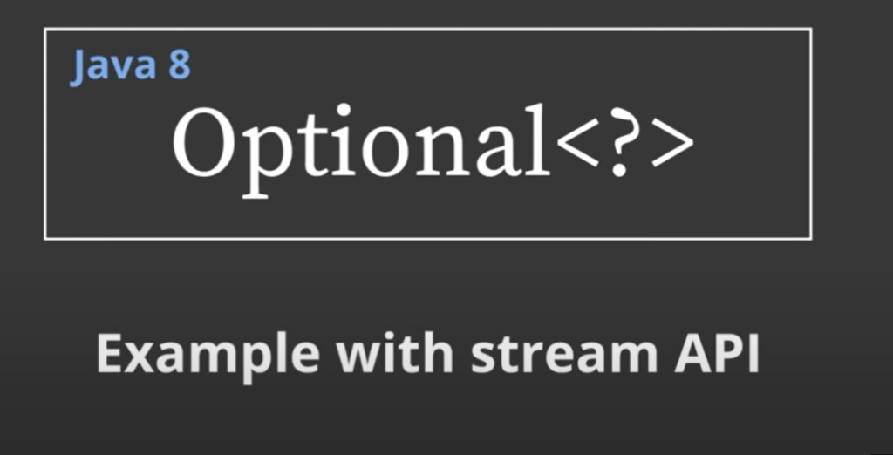

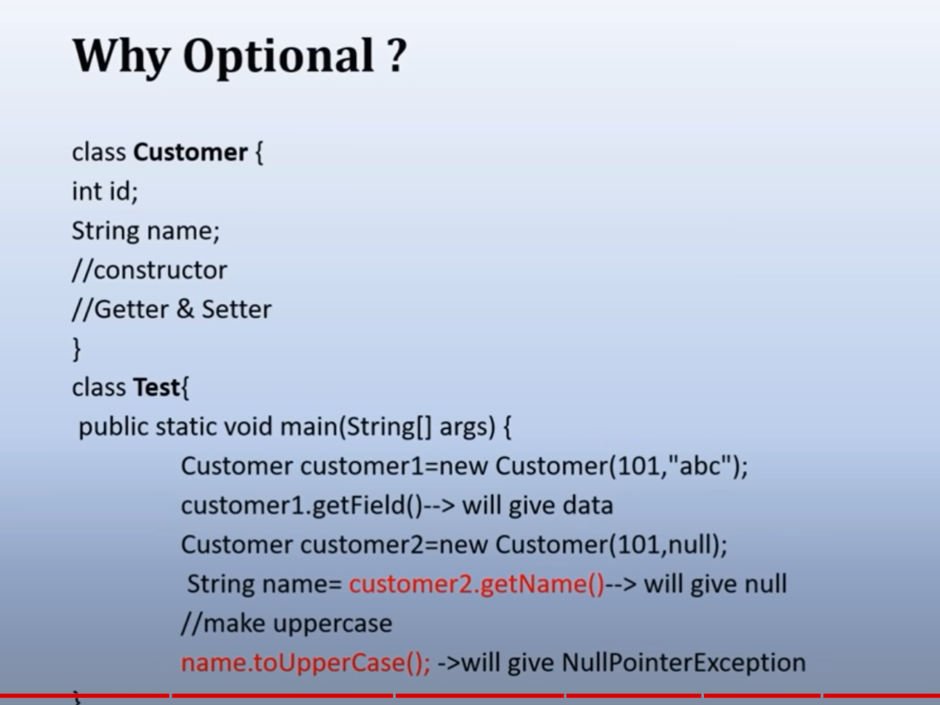

Checking 100 null check is not good if 100 field are there

Optional.of ----- internally it will do null check

OfNullable

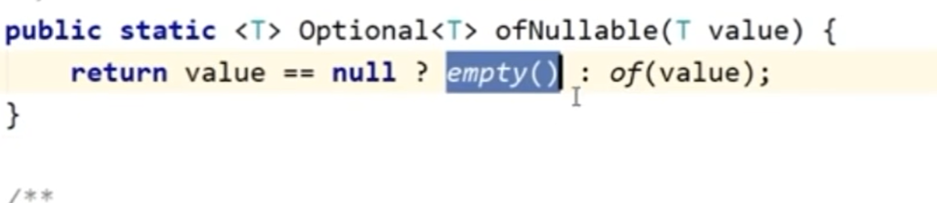

If object is null it will give empty object rather than throwing the exception

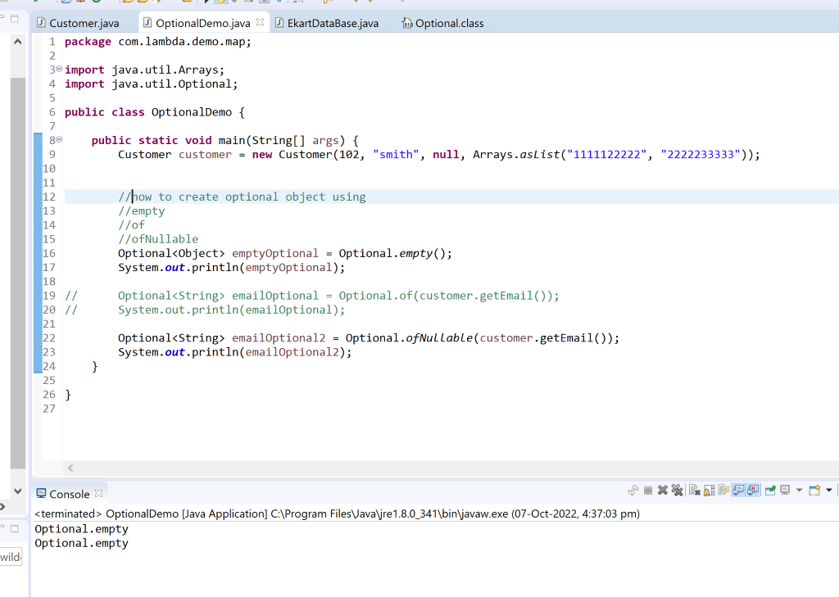

Requirement  : if email is null we want to return something

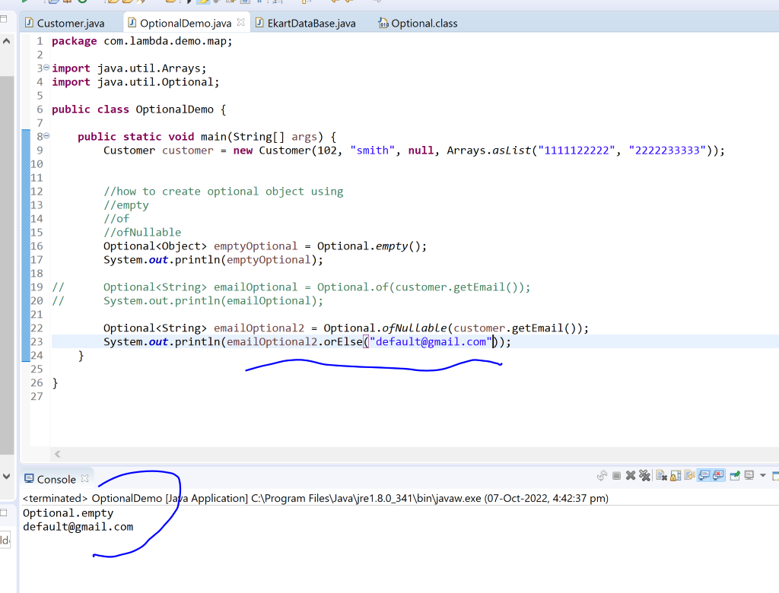

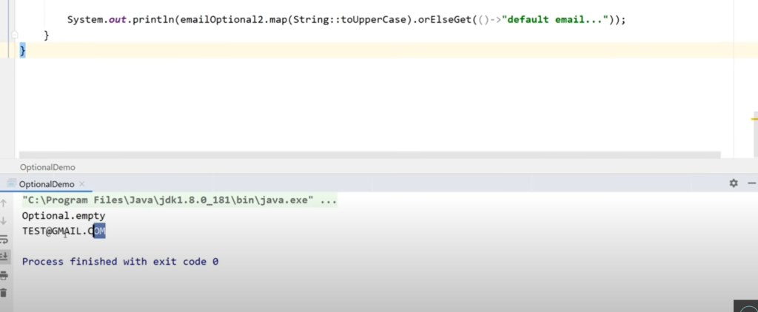

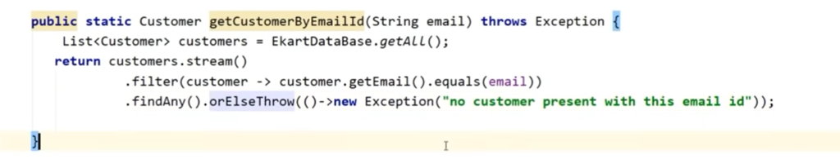

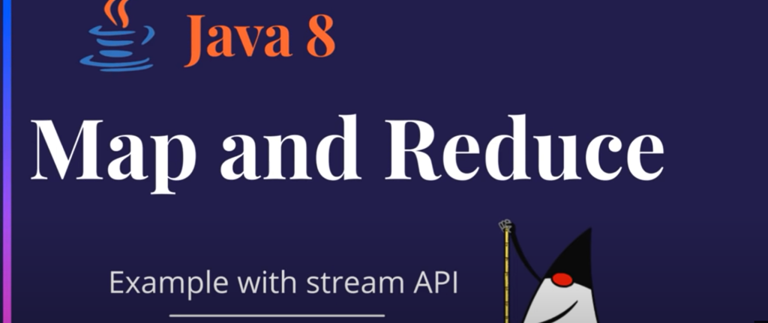

**Reduce**: combine stream of element and produce a single output

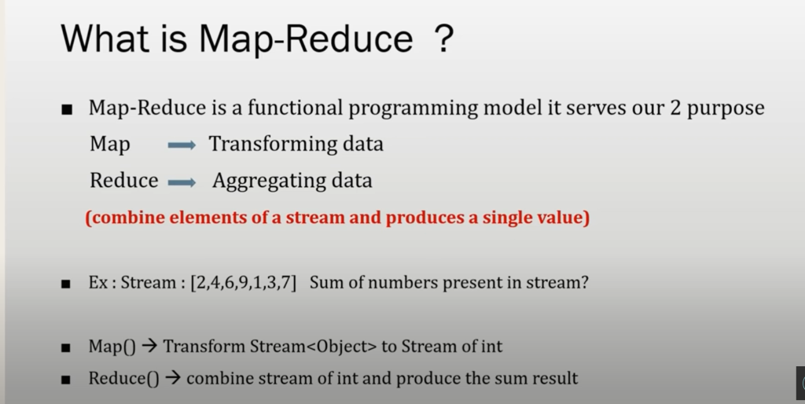

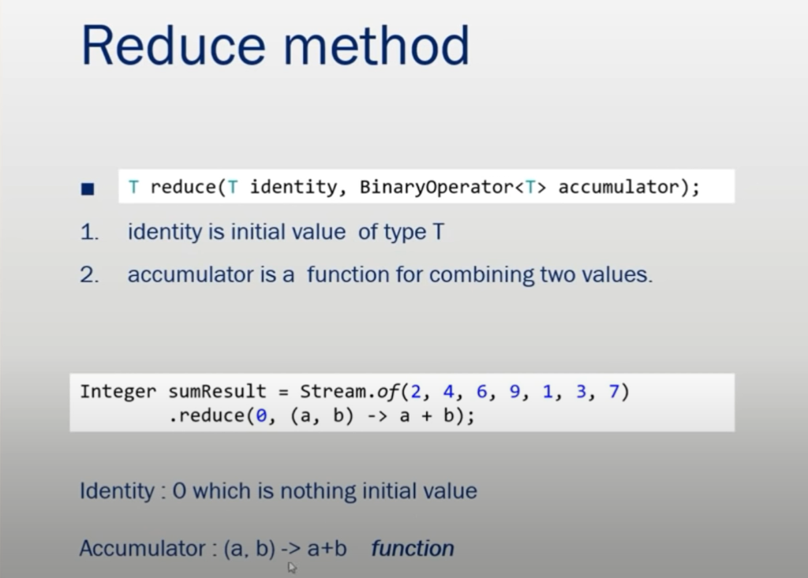

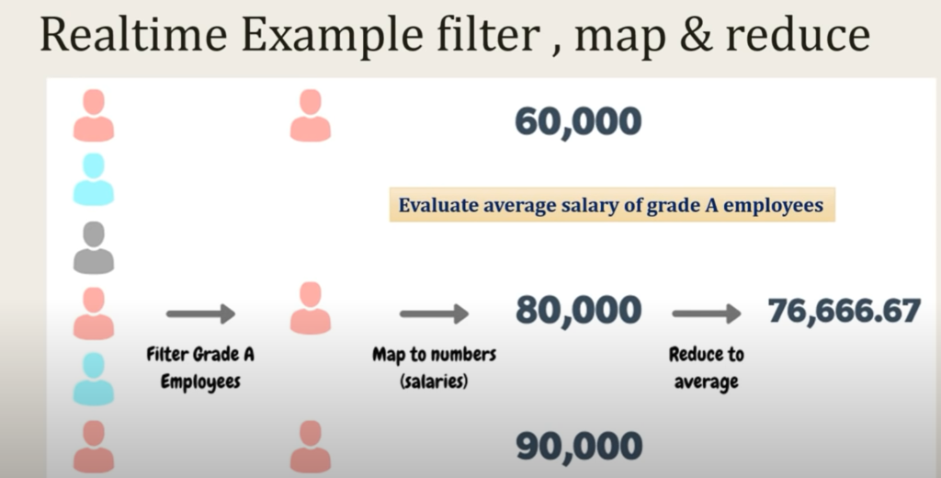

**Find a longest string from list of string**

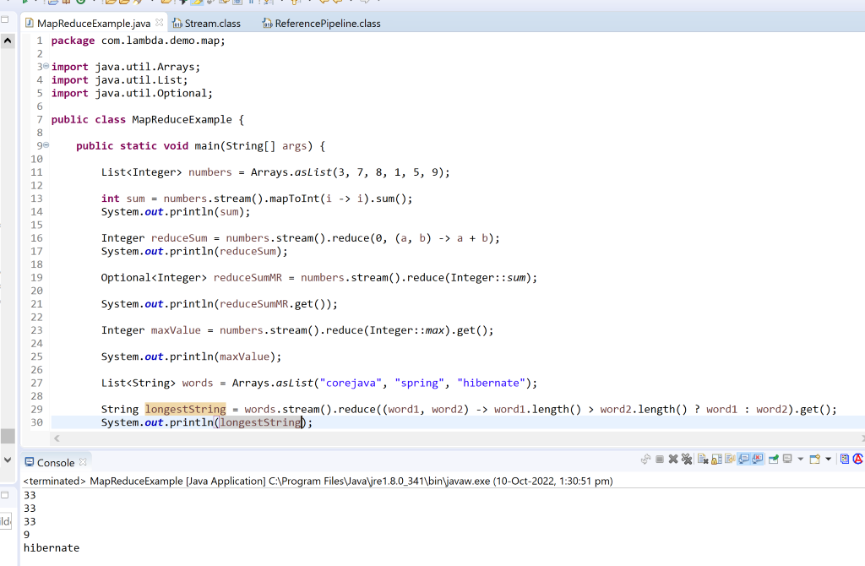

**We need to find avg salary of emp whose grade is A**

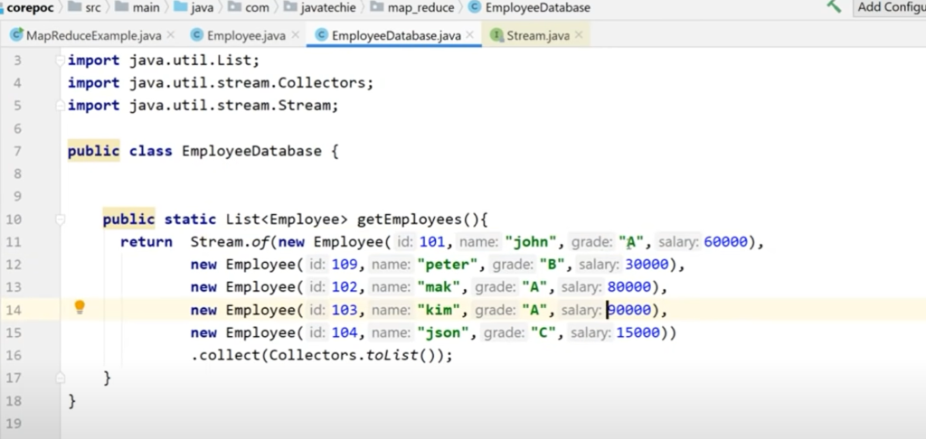

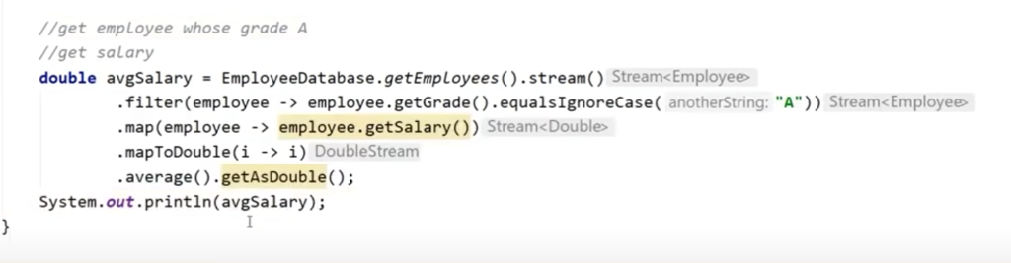

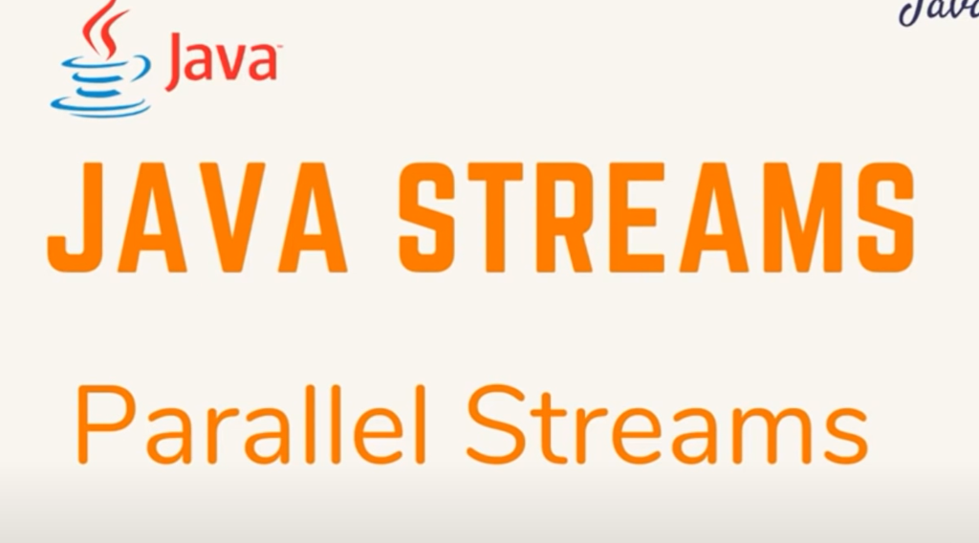

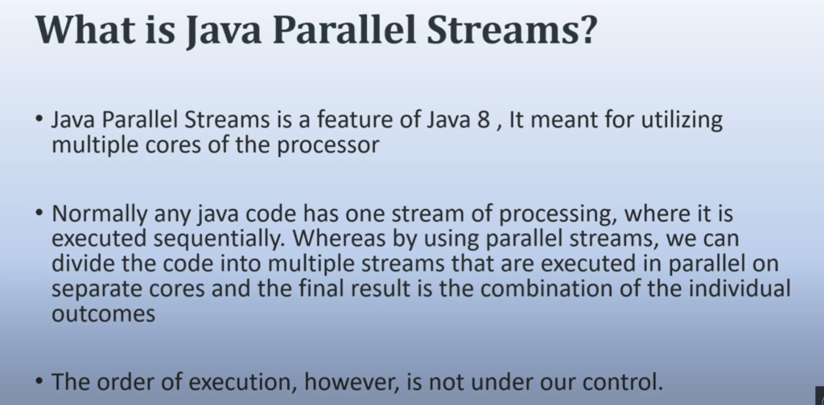

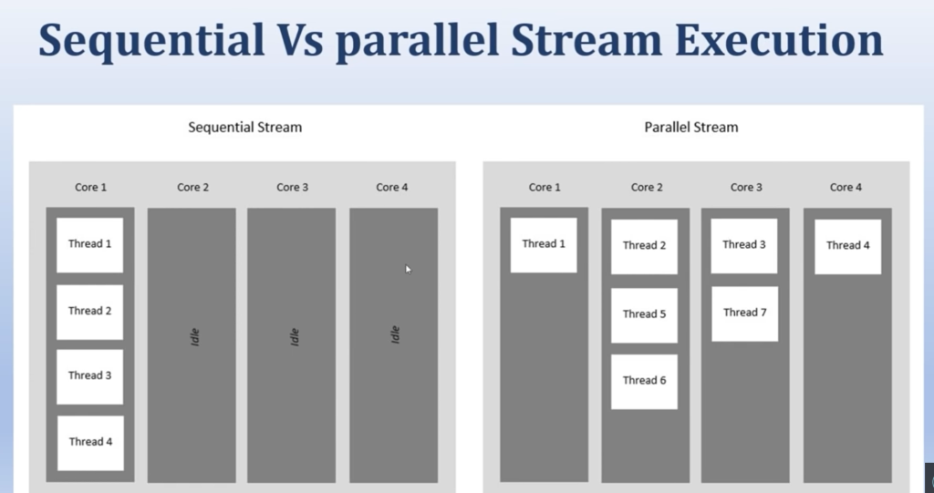

Requirement :

Iterate 100 record using normal stream and parallel stream then we evaluate the performance

Note :

Order is not maintained in parallel stream but response time will be less

